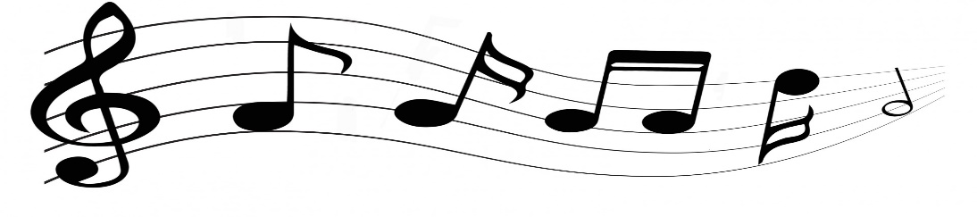
Beginning Band Information

Dear Parents,
My name is Ruthann Pyle and I am the 5th grade band director for GE and NGE. In 5th grade, your student has the opportunity to take band. I am sending this letter to you in hopes that you would take advantage of this opportunity to have your child participate in band. I met the students in their music class and we learned about all the instruments they can play in band this year.
Next week, each 5th grade class will have a chance to try the instruments and pick their top three choices! Every student gets to participate, even if they are not sure they want to join. It’s easy to sign up for band! Students just need to participate in the instrument testing and turn in a band permission slip.

Frequently Asked Questions

How can I become involved in band?
If your child wishes to be in band, just sign up! Turn in a signed permission slip. Please do not rent an instrument until after we have done the testing and selection process, and have assigned your student an instrument.

What instrument can I play?
We will be starting a certain number of students on the following instruments: flute, clarinet, alto saxophone, French horn, trumpet, trombone, baritone, tuba, and percussion (mallets and snare drum). We consider many things when selecting an instrument for each student, including physical characteristics, students' preferences, and the need for a balanced instrumentation.

When do I find out what I play?
I will test each student to see which instrument would be the best match. After all permission slips have been turned in I will assign instruments based on the student’s top 3 choices and what I think will be the best fit. Students will find out ASAP what instruments they are assigned.

What is the first day the students will need their instruments?
Instruction will begin the same week that they receive their instrument! If your child is using a school-owned instrument, they can take them home once I teach the students how to properly assemble and care for them.

How much will it cost?
Students are required to provide their own band method books, $12, and needed band supplies. Students may purchase their own instrument, but are encouraged to rent the instrument for at least a year. We strongly recommend that you acquire a quality instrument for your child. It is strongly advised to not purchase a colored (blue, green, red ect.) instrument. Although they may look fun, these instruments break down easily and are prone to problems. There are some instruments that we provide like tenor sax, bass clarinet, and baritone, due to the extremely high price of these instruments. The school owns a few instruments other than the ones listed above for those who wish to be in band, but simply cannot afford it.

My Mom has Uncle Joe's old clarinet up in the closet. Can I play that?
One of the things that can frustrate any student is trying to play on an instrument that is in poor condition. In many cases, quality used instruments are a good alternative to the prices of new instruments. However, it is extremely important that used instruments go through a thorough cleaning and repair at a music repair store. Please bring the instrument in so I can take a good look at it, and make any needed repairs.

Please email me any financial concerns that you may have. We can work together to find a solution so that your child can have this wonderful music education opportunity!

Ruthann Pyle

Ruthann.pyle@irsd.k12de.us
North Georgetown Elementary School
Georgetown Elementary School

